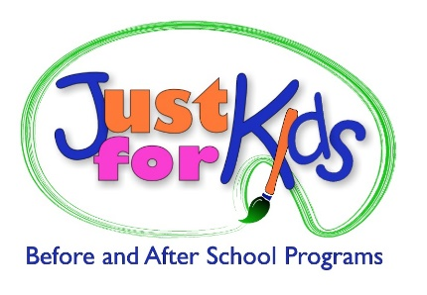

**Curriculum Development Internship**

Just for Kids, a not-for-profit youth program, has an opportunity for a Curriculum Development intern at our administrative office in Williamsville, NY! We manage before and after school programs along with summer camps for a variety of school districts, private and charter schools. Our internship program offers you hands-on experience in a fast paced and rewarding environment.

Our team will provide you with an enriching internship experience in youth curriculum programming and planning, long range planning, and activity development for our programs- focusing on kindergarten through sixth grade students. You will also gain experience by periodically visiting our sites to facilitate the activities that you have planned under the supervision of the Program Manager.

We prefer that our interns work 10-15 hours a week during our office hours (Monday- Friday 8:30am-5pm) and are flexible with school schedules. While this is an unpaid internship, we will provide documentation per college requirements for course credit.

**Key competencies:**

* Elementary Education, Early Childhood Education, or related major interested in expanding experience with development and facilitation of planned activities, from Character Education, Academic Enrichment and Literacy skills, the Sciences, and relevant youth initiatives.
* The ability to modify activities to work with typical youth and youth with social, emotional, or other special needs.
* Strong communication (written and verbal), strong organizational skills, reliable.
* Able to work well independently and as part of a team.
* Able to follow direction, contribute openly, and have a flexible, proactive, can-do attitude.

***We have been recognized:***

* Child Care Provider of the Year, Child Care Resource Network (2015)
* Employer of the Year – Buffalo State (2012) & University at Buffalo (2015)
* Buffalo Business First - Best Places to Work Finalist (2015)
* UB Nonprofit Internship Site of the Year (2015)

Please visit [www.justforkidsonline.org](http://www.justforkidsonline.org) for additional program information

To apply, please send your resume and reasons for interest in the internship position to: [hr@justforkidsonline.org](mailto:hr@justforkidsonline.org).

Internships available: Fall Semester, Spring Semester, Summer Break